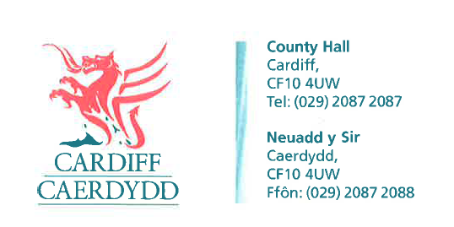
FOI Response Document
FOI18164
Thank you for your request under the Freedom of Information Act 2000 about Software Contracts received on 27/07/2022.
Request:
1. The Name of the housing management software used by the Local Authority (this software is what is used to manage tenants and rents etc..) - If the LA uses their own in-house software please state.
Response: NEC Housing.
2. Could you please confirm the start and end date for the contract for this software?
Response: 01/03/2019 – 29/02/2024.
3. The Name of the asset management software used by the Local Authority (this software is that used to manage properties) If the LA uses their own in-house or this is part of the housing management package software please state.
Response: In-house database.
4. Could you please confirm the start and end date for the contract for this software?
Response: This is not applicable, as it's an in-house database.
If you have any queries or concerns, please do not hesitate to contact us.
Please remember to quote the reference number above in any future communications.

